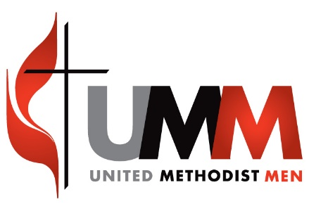
www.gcumm.org/groups/wocumm

WOCUMM EXECUTIVE LEADERSHIP TEAM MEETING AGENDA
Saturday, April 16, 2016
10 AM – 1 PM
Library Room L-1 – MTSO
- Welcome by John Sherer
- Introductions
- Devotions and opening prayer by Pastor Keith Deel
- Business as follows:

- Election of Officers
- Recognitions
- Secretary’s Report-John Sherer
- Treasurer’s Report-Rodger Southward reported we have $1,775.63 balance.
- Web-Master’s Report – Ted Rose
- Report on the NACP meeting held 3/3-6/16, Nashville, TN - Chuck Craynon
- Report from the District Presidents & other reports
- Meals for Millions report- George “Tater” Jensen
- Lee Donley-WOCUMM training report & planning
- Goals & Expectations for 2016 –All
- Man in the Mirror cooperation-Leo Scholl
- District Organizational Chart- hand out copies
- Upcoming Men’s ministry programs
- Men’s training webinar- May 24th -8 PM EST -hand outs
- Love Packages Report –Leo Scholl
- Plans for Lakeside-devotions, Potato drop, Program Book, UMMen Video
- OTHER-
- New President’s Comments
- Next Meeting?
- Closing Prayer
- Adjournment

